Data description:

We have data in 3 different excel sheets. I have imported the data into the Jupyter notebook using the Pandas library. The 3 datasets and their respective columns are -

Customers – CustomerID, State, Salary, Gender, Smoker, Age, Occupation

Policy Details – PolicyID, CustomerID, Agent, Elimination Period, Income Replacement percent, Monthly Benefit, Annualized premium, product, policy effective date

Claims – PolicyID, Date of Loss, Diagnosis Category, Length of disability, Fraud, Amount paid, Amount recovered

|  |  |
| --- | --- |
| PolicyID | A unique ID identifying each policy |
| CustomerID | A unique ID identifying each insured |
| Gender | 1=Male, 0=Female |
| Smoker | 1=Smoker, 0=Non-smoker |
| Elimination Period | The number of days after the date of loss (i.e., the date of the accident, injury, or illness) that the policy goes into effect. For example, if you had a 14-day elimination period, you would not get benefits until 14 days after you became sick or injured. |
| Income Replacement Percent | The percent of your income the policy replaces. |
| Monthly Benefit | The monthly amount the insured receives while on disability |
| Annualized Premium | The annualized amount of premium the insured pays to us |
| Latitude | The latitude of the insured's home address |
| Longitude | The longitude of the insured's home address |
| Product | The product the insured purchased (Disability or Life) |
| Policy Effective Date | The effective date of the policy. The customer may purchase a policy on 5/2/2015, for example, with an effective date of 6/2/2015 |
| Date of Loss | This the date the accident, injury or illness occurred or was diagnosed. |
| Diagnosis Category | The type of diagnosis. |
| Length of Disability (in Days) | The number of days the insured collected disability |
| Fraud | An indicator of fraud. If "Yes", the claim was found to be fraudulent. If "No" the claim was not found to be fraudulent |
| Amount Paid | The amount of money the company paid the insured for the claim |
| Amount Recovered | The amount of money the company recovered on a fraudulent claim. |
| Fraud | 1=Confirmed fraud, 0=No fraud confirmed |

I inner joined customers and policydetails on ‘CustomerID’ and then, inner joined this data with Claims on ‘PolicyID’.

Data Preparation:

I filtered the policy data where we have cases only related to ‘Disability’ insurance. There are a few duplicated rows in the final data. I removed the duplicates and kept the first instance only. Later, I dropped irrelevant columns like PolicyID, CustomerID, date variables, etc. The final data has 30,838 rows and 12 columns. There are no null values. But there is a class imbalance.

|  |  |
| --- | --- |
| Fraud | 14.78% |
| Non-Fraud | 85.22% |

I want to see if fraudsters take advantage of the system and have a longer disability period. But the distribution of the length of disability for fraudsters and non-fraudsters shows no significant difference. They have almost similar means and similar distribution.

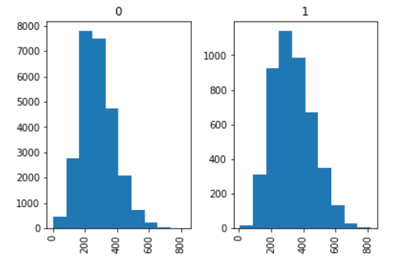

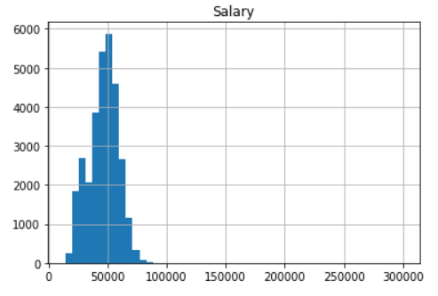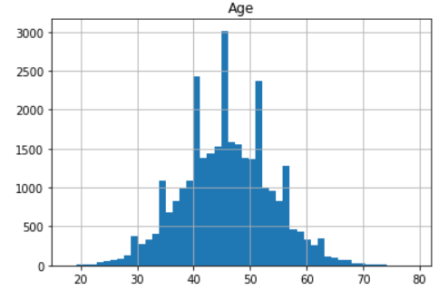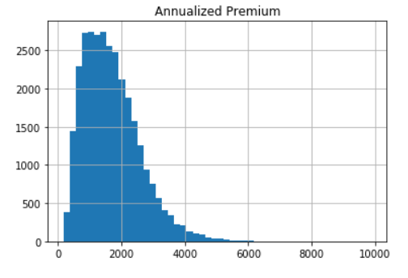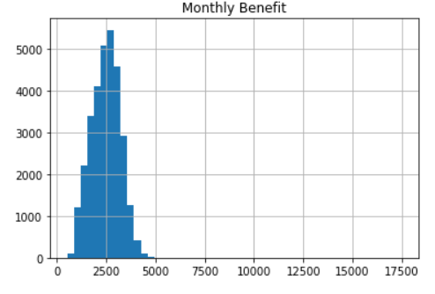

The distributions of the continuous variables are kind of normal in the data. But the scale of measurement is very different. This will cause an undue extra impact of some variables compared to the others while modeling some algorithms. So, it is advised to standardize the continuous variables. I used standardscaler in sklearn to standardize the variables.

Variables occupation, agent, elimination period and income replacement percent are categorical in nature. Using categorical variables as it is will cause problems in modeling. So, I created dummy variables using pandas. I dropped the original variables after the dummies were created. Now that the data is ready, I separated them into independent and target variables and split them to 80%:20% training and validation split. The purpose of creating a validation set is to ensure that our model is not overfitting.



Sampling:

To address the class imbalance issue, I used SMOTE oversampling followed by Tomek links cleaning. This will synthetically create new training instances of one level to match that of the other level. Cleaning is done by Tomek links. Now, the training data has 40,738 rows of equally distributed Fraud proportion.

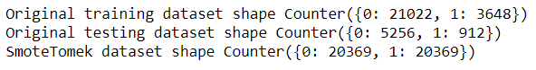

Model: Naïve Bayes Classifier

**Naive Bayes** is an extremely fast algorithm relative to other [classification algorithms](https://courses.analyticsvidhya.com/courses/introduction-to-data-science-2/?utm_source=blog&utm_medium=6stepsnaivebayesarticle). It is a [classification technique](https://courses.analyticsvidhya.com/courses/introduction-to-data-science-2/?utm_source=blog&utm_medium=6stepsnaivebayesarticle) based on Bayes’ Theorem with an assumption of independence among predictors. In simple terms, a Naive Bayes classifier assumes that the presence of a feature in a class is unrelated to the presence of any other feature. In Gaussian Naive Bayes, each feature is assumed to be distributed normally.

I ran Gaussian Naïve Bayes on the SMOTETomek over sampled training data and validated the model in the validation data. The results are published in the table below.

|  |  |  |
| --- | --- | --- |
| Metrics in % | Training data | Validation Data |
| Accuracy | 66.71 | 51.11 |
| Recall | 87 | 83 |
| Precision | 62 | 21 |
| AUC | 72 | 69 |
| F1 Score | 72 | 34 |

The accuracy of the training data is 66.71%, but it is low on validation data at 51.1%. This low accuracy on training data could be that the model is overfitting on the training data and is not that great at capturing the true trend. But the validation data is having a class imbalance. So, accuracy might not be the correct metric to look at. Sensitivity on the training and validation data is great. It is the most important metric to look at in this particular scenario. The validation precision has dropped compared to the training precision. This means our confidence in catching true positives has dropped and our model is flagging more other cases as true positives. The AUC of 69% says that the classifier does a decent, but not so great job of classifying fraud and non-fraud cases.

We can find alter the cut-offs to make the model highly sensitive in finding the true positives, but that is also increasing the false positives. Machine learning cant help beyond this point. It requires a business understanding for evaluation between what is the desired sensitivity of the model and what percent of false positives we can afford to achieve that sensitivity.

Overall, I find a need to bring more data to improve the accuracy of the model. More features that will account for Fraud cases need to be brought in the model.

